Asymmetric DCC correlation: GBPUSD and EURGBP
Method 10 / GARCH(1,1) + Cappiello-Engle-Sheppard ADCC / Alpari D1 full available history

Study setup
Logical pair: GBPUSD , EURGBP
Broker symbols: GBPUSD_i , EURGBP_i
Snapshot: 2026-11-03_majors_alpari_D1
Timeframe: D1
Matched return window: 1999-01-06 to 2026-11-02 (UTC bar dates)
Matched return count n: 7199
Dropped unfinished last bar dated 2026-11-03 UTC after a tick-volume check against the prior complete day.
GBPUSD GARCH(1,1): mu=0.000012, omega=0.004023, alpha=0.055488, beta=0.932103
EURGBP GARCH(1,1): mu=-0.000021, omega=0.000658, alpha=0.046506, beta=0.951826
ADCC: a=0.024752, b=0.972137, g=0.000000, a+b+g/2=0.996889
Nested DCC (g=0): a=0.024752, b=0.972137
Negative shock: n = min(z, 0) in broker quote direction (not inverted)
Burn-in ignored in path summaries and chart: first 60 updates
Complete matched rows (Excel): GBPUSD-EURGBP_ADCC_D1.xlsx
Complete matched rows (HTML table): GBPUSD-EURGBP_ADCC_D1_data.html

Method carried forward
Asymmetric DCC extends Engle DCC with an extra term on joint negative standardised shocks. Each matched daily log return of close, ln(close_t / close_t-1), is first filtered by a constant-mean GARCH(1,1). Then z = residual / sigma and n = min(z, 0). The Cappiello-Engle-Sheppard recursion uses A = (1-a-b) Q_bar - g N_bar with N_bar = mean(n n'). Quotes are not inverted, so a negative shock is a negative log return in the broker quote. Nested symmetric DCC (g = 0) is fit on the same z path for comparison. Constraints: a,b,g >= 0 and a + b + g/2 < 1. Path summaries ignore the first 60 updates. The headline is latest ADCC rho. Pearson r is a side check only. This is not a cause, lead, or trading signal.

Results
Latest ADCC rho: -0.370867
Latest nested DCC rho: -0.370867
Post-burn-in ADCC path (n=7139): mean=-0.358343, median=-0.366305, min=-0.877857, max=0.240613, std=0.221201
Share of post-burn-in days with |rho| >= 0.4: 44.57%; |rho| >= 0.7: 6.39%
Same-sample Pearson r: -0.397845
ADCC minus r: 0.026978
ADCC minus nested DCC: -0.000000

Conclusion
Over 7199 matched daily log-return rows for GBPUSD and EURGBP (broker quote directions unchanged), latest ADCC rho is -0.3709 (negative, weak conditional linear link in this sample) with fitted a=0.0248, b=0.9721, g=0.0000. Nested symmetric DCC latest rho is -0.3709 (ADCC minus DCC = -0.0000). After a 60-day burn-in, path mean is -0.3583 and std is 0.2212. Same-sample Pearson r is -0.3978 (ADCC minus r = 0.0270). This does not establish cause, lead-lag, or a lasting trading rule.

Charts
Daily closes

Daily log returns
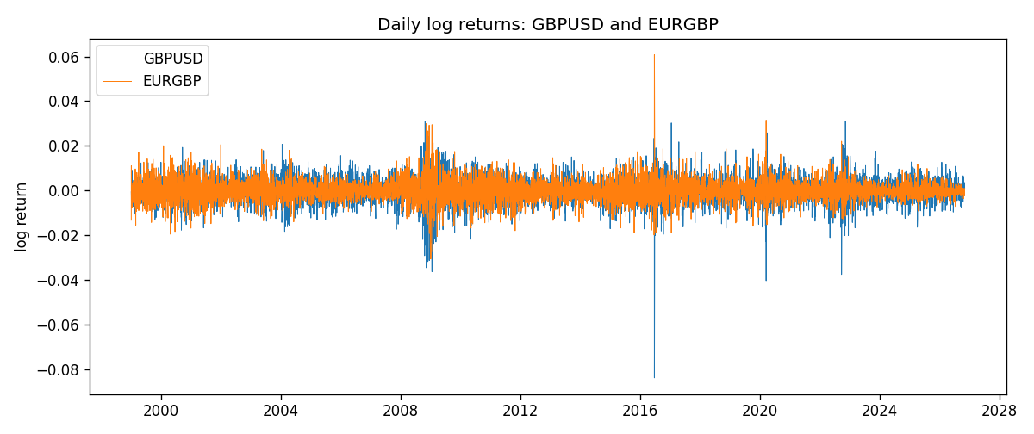
ADCC rho path with nested DCC and Pearson r
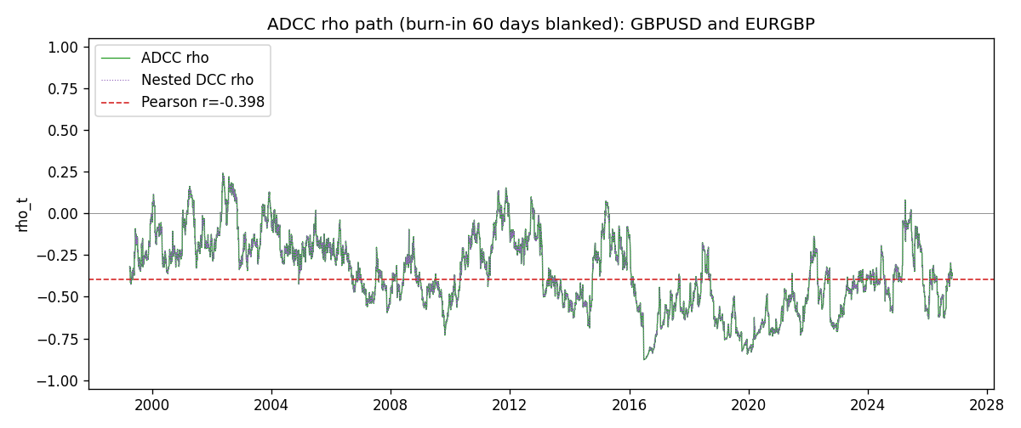

Data report
Every matched row that entered the ADCC recursion is stored in the sibling Excel workbook named GBPUSD-EURGBP_ADCC_D1.xlsx. Embedding all rows as a Word table is impractical at this length; the Word file holds the column list, column summaries, and the first and last 15 matched rows.
Columns: time, GBPUSD_open, EURGBP_open, GBPUSD_high, EURGBP_high, GBPUSD_low, EURGBP_low, GBPUSD_close, EURGBP_close, GBPUSD_tick_volume, EURGBP_tick_volume, GBPUSD_spread, EURGBP_spread, GBPUSD_real_volume, EURGBP_real_volume, GBPUSD_log_return, EURGBP_log_return, GBPUSD_sigma, EURGBP_sigma, GBPUSD_z, EURGBP_z, GBPUSD_n, EURGBP_n, q11, q22, q12, rho_adcc, rho_dcc
Column summaries (matched calculation rows)
column | count | mean | std | min | 25% | 50% | 75% | max
GBPUSD_open | 7199 | 1.5160931 | 0.21831499 | 1.06854 | 1.324955 | 1.5114 | 1.63186 | 2.1066
EURGBP_open | 7199 | 0.78665041 | 0.09676322 | 0.5734 | 0.6873 | 0.83367 | 0.865175 | 0.9769
GBPUSD_high | 7199 | 1.5223838 | 0.21887686 | 1.08366 | 1.32978 | 1.5181 | 1.6384 | 2.1161
EURGBP_high | 7199 | 0.78972718 | 0.09713886 | 0.5789 | 0.68935 | 0.83657 | 0.86804 | 0.9799
GBPUSD_low | 7199 | 1.5097628 | 0.21753729 | 1.03518 | 1.3194 | 1.50323 | 1.62442 | 2.0983
EURGBP_low | 7199 | 0.78395066 | 0.09658082 | 0.5682 | 0.6853 | 0.83147 | 0.862765 | 0.9661
GBPUSD_close | 7199 | 1.5161471 | 0.21826306 | 1.06879 | 1.325055 | 1.51122 | 1.63216 | 2.1065
EURGBP_close | 7199 | 0.78669405 | 0.09676312 | 0.5735 | 0.6875 | 0.8337 | 0.86528 | 0.977
GBPUSD_tick_volume | 7199 | 94850.986 | 153561.38 | 62 | 9998.5 | 52911 | 91818.5 | 1273370
EURGBP_tick_volume | 7199 | 86949.029 | 145390.09 | 154 | 6517.5 | 44265 | 81326 | 1424684
GBPUSD_spread | 7199 | 26.96055 | 19.19062 | 0 | 11 | 20 | 50 | 50
EURGBP_spread | 7199 | 21.393666 | 19.14328 | 0 | 4 | 13 | 50 | 50
GBPUSD_real_volume | 7199 | 3.5570778e+09 | 8.4449923e+10 | 0 | 0 | 0 | 0 | 2.4038164e+12
EURGBP_real_volume | 7199 | 2.7805214e+10 | 1.3507095e+11 | 0 | 0 | 0 | 0 | 3.5726265e+12
GBPUSD_log_return | 7199 | -3.133e-05 | 0.00564236 | -0.08388241 | -0.00313644 | 2.978e-05 | 0.00317207 | 0.03112653
EURGBP_log_return | 7199 | 2.179e-05 | 0.00487166 | -0.03067367 | -0.0026225 | -0.00010035 | 0.00256076 | 0.06075387
GBPUSD_sigma | 7199 | 0.00539273 | 0.00169347 | 0.00300164 | 0.00447716 | 0.00503308 | 0.00576693 | 0.02200919
EURGBP_sigma | 7199 | 0.00463549 | 0.0016933 | 0.00185782 | 0.00343492 | 0.00442306 | 0.00552784 | 0.01547738
GBPUSD_z | 7199 | -0.00686212 | 1.0000314 | -10.304072 | -0.59987586 | 0.00324524 | 0.60720629 | 4.9487754
EURGBP_z | 7199 | 0.0079082 | 1.0000682 | -3.7920434 | -0.62249972 | -0.01982896 | 0.59754993 | 8.4811201
GBPUSD_n | 7199 | -0.38661785 | 0.61031244 | -10.304072 | -0.59987586 | 0 | 0 | 0
EURGBP_n | 7199 | -0.37944238 | 0.57002657 | -3.7920434 | -0.62249972 | -0.01982896 | 0 | 0
q11 | 7199 | 1.0012802 | 0.21332465 | 0.5365382 | 0.89170662 | 0.97903212 | 1.0717737 | 4.0016569
q22 | 7199 | 1.0014936 | 0.1914178 | 0.62130603 | 0.87485758 | 0.97668459 | 1.0970698 | 2.9971745
q12 | 7199 | -0.36492912 | 0.27279773 | -3.0349848 | -0.50345744 | -0.3351132 | -0.19143364 | 0.25376355
rho_adcc | 7199 | -0.35760191 | 0.22046381 | -0.87785669 | -0.51941352 | -0.36215203 | -0.20096551 | 0.24061333
rho_dcc | 7199 | -0.35760191 | 0.22046378 | -0.87785683 | -0.51941345 | -0.36215199 | -0.20096554 | 0.24061331
First 15 matched rows (selected columns)
time | GBPUSD_log_return | EURGBP_log_return | GBPUSD_z | EURGBP_z | GBPUSD_n | EURGBP_n | q11 | q22 | q12 | rho_adcc | rho_dcc
1999-01-06 | -0.00060452184 | -0.013303338 | -0.1487951 | -2.3696655 | -0.1487951 | -2.3696655 | 1 | 1 | -0.36439289 | -0.36439289 | -0.36439289
1999-01-07 | -0.002118709 | 0.011051402 | -0.52590778 | 1.7920379 | -0.52590778 | 0 | 0.97579565 | 1.11424 | -0.34664575 | -0.33244291 | -0.33244291
1999-01-08 | -0.0058954193 | -0.004943862 | -1.4791 | -0.75869826 | -1.4791 | -0.75869826 | 0.95856367 | 1.1657943 | -0.36144844 | -0.34192032 | -0.34192032
1999-01-11 | -0.0056851331 | -0.0012752393 | -1.3734121 | -0.19525911 | -1.3734121 | -0.19525911 | 0.98911753 | 1.1506704 | -0.32473402 | -0.30438859 | -0.30438859
1999-01-12 | 0.0022657001 | 0.0033970309 | 0.52776312 | 0.54439082 | 0 | 0 | 1.0113578 | 1.1226636 | -0.31018158 | -0.29109769 | -0.2910977
1999-01-13 | 0.0091330396 | 0.00042381861 | 2.1689188 | 0.072019754 | 0 | 0 | 0.99318335 | 1.1018291 | -0.2955609 | -0.28253688 | -0.28253688
1999-01-14 | 0.0019376331 | -0.0019793588 | 0.415319 | -0.3247595 | 0 | -0.3247595 | 1.0850612 | 1.0743678 | -0.28459275 | -0.26358471 | -0.2635847
1999-01-15 | -0.0017558204 | -0.0076715819 | -0.38893765 | -1.2958103 | -0.38893765 | -1.2958103 | 1.0622083 | 1.050154 | -0.28113521 | -0.2661852 | -0.2661852
1999-01-18 | 0.0012112405 | 0.00071280921 | 0.26940379 | 0.12233838 | 0 | 0 | 1.039467 | 1.0655665 | -0.26196051 | -0.24890877 | -0.24890877
1999-01-19 | 0.0018745281 | -0.0014261269 | 0.42779515 | -0.23984861 | 0 | -0.23984861 | 1.0154114 | 1.0393577 | -0.25497921 | -0.24819969 | -0.24819969
1999-01-20 | -0.0049053846 | 0.0019960086 | -1.1503992 | 0.35200566 | -1.1503992 | 0 | 0.99475953 | 1.0149326 | -0.25154797 | -0.25034744 | -0.25034744
1999-01-21 | 0.0031518998 | -0.00071240297 | 0.72476342 | -0.12320257 | 0 | -0.12320257 | 1.0029109 | 0.99283119 | -0.25569599 | -0.25624478 | -0.25624478
1999-01-22 | 0.0024781662 | -0.0017118406 | 0.57425945 | -0.30834459 | 0 | -0.30834459 | 0.99107941 | 0.96865428 | -0.25191524 | -0.25710814 | -0.25710813
1999-01-25 | 0.0012066366 | -0.0054402425 | 0.28216227 | -1.0094203 | 0 | -1.0094203 | 0.97473828 | 0.94712866 | -0.25041253 | -0.26061989 | -0.26061988
1999-01-26 | 0.00072328374 | -0.00057438255 | 0.17158646 | -0.10301723 | 0 | -0.10301723 | 0.95266046 | 0.94907037 | -0.25161877 | -0.26462127 | -0.26462127
Last 15 matched rows (selected columns)
time | GBPUSD_log_return | EURGBP_log_return | GBPUSD_z | EURGBP_z | GBPUSD_n | EURGBP_n | q11 | q22 | q12 | rho_adcc | rho_dcc
2026-10-13 | 0.0036434319 | 0.00020130374 | 0.99012057 | 0.1102307 | 0 | 0 | 0.74578907 | 0.72479622 | -0.22402472 | -0.30470527 | -0.30470523
2026-10-14 | -0.0049164679 | 0.0011241873 | -1.3326792 | 0.57720724 | -1.3326792 | 0 | 0.75238551 | 0.70801264 | -0.21621471 | -0.29624056 | -0.29624052
2026-10-15 | 0.0065976411 | -0.00087557391 | 1.7297814 | -0.43430378 | 0 | -0.43430378 | 0.7784935 | 0.69964265 | -0.23036414 | -0.31213987 | -0.31213983
2026-10-16 | 0.0037592051 | -0.0020380844 | 0.92761754 | -1.0367143 | 0 | -1.0367143 | 0.83397561 | 0.68792795 | -0.24367424 | -0.32170771 | -0.32170767
2026-10-19 | -0.0017500314 | -0.00056950988 | -0.43510037 | -0.27928901 | -0.43510037 | -0.27928901 | 0.83514797 | 0.69847415 | -0.26182196 | -0.34280661 | -0.34280658
2026-10-20 | 0.0055923442 | -0.0035906254 | 1.4014894 | -1.8427848 | 0 | -1.8427848 | 0.81967482 | 0.68405397 | -0.25265244 | -0.33740967 | -0.33740964
2026-10-21 | 0.0012476328 | -0.00140647 | 0.30055836 | -0.67367822 | 0 | -0.67367822 | 0.84856478 | 0.75216032 | -0.31067282 | -0.388871 | -0.38887098
2026-10-22 | 0.00022396082 | -0.0018743924 | 0.052659095 | -0.90641913 | 0 | -0.90641913 | 0.83026788 | 0.74554721 | -0.30816189 | -0.39168076 | -0.39168075
2026-10-23 | -0.0021146949 | 0.00082421033 | -0.53923001 | 0.412095 | -0.53923001 | 0 | 0.81031341 | 0.74822113 | -0.30189054 | -0.3877109 | -0.38771088
2026-10-26 | -0.0024340661 | 0.00013133309 | -0.62840764 | 0.075161071 | -0.62840764 | 0 | 0.79804352 | 0.7346876 | -0.30011279 | -0.39194024 | -0.39194022
2026-10-27 | -0.0023648393 | -0.0019957343 | -0.61663936 | -0.9909887 | -0.61663936 | -0.9909887 | 0.7886929 | 0.71746749 | -0.29405334 | -0.39090484 | -0.39090481
2026-10-28 | 0.0015771808 | 0.00066967224 | 0.41026082 | 0.34411891 | 0 | 0 | 0.77924015 | 0.72489563 | -0.27186789 | -0.36172999 | -0.36172997
2026-10-29 | 0.0035881935 | -0.0011722209 | 0.95211775 | -0.58142864 | 0 | -0.58142864 | 0.764805 | 0.71073964 | -0.26193184 | -0.35526928 | -0.35526926
2026-10-30 | 0.0013450605 | -0.0024205543 | 0.35304038 | -1.2214553 | 0 | -1.2214553 | 0.76904461 | 0.70241473 | -0.26946976 | -0.36663799 | -0.36663796
2026-11-02 | 0.0010971256 | 0.00089940465 | 0.29222275 | 0.45973087 | 0 | 0 | 0.75381244 | 0.72288339 | -0.27376882 | -0.37086701 | -0.37086699

